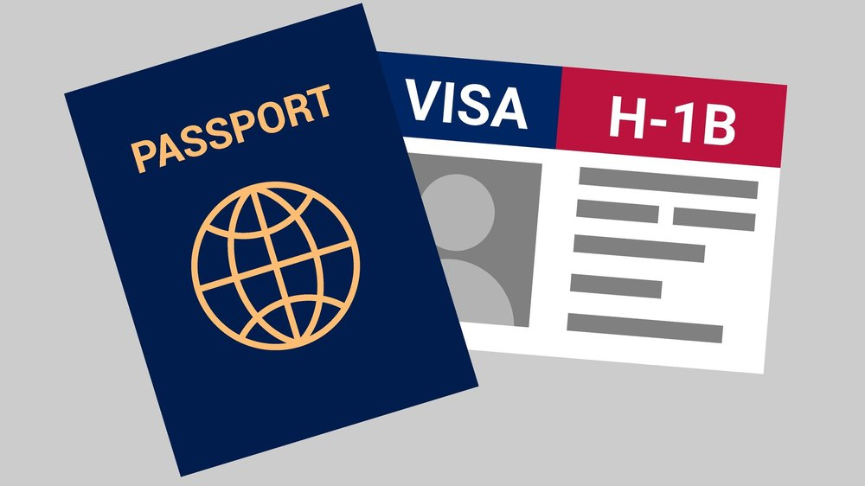

**H1B VISA Applications**

Authored by

Momoreoluwa Ayinde

Sophomore Computer Science Major

Quinnipiac University

Revision Date: Apr 30,2023

Purpose of Document:

The purpose of this document is to analyze the trends and patterns in H1B Visa applications submitted to the United States Citizenship and Immigration Services (USCIS) from 2015 to 2018. This report aims to provide insights into the companies, and occupations, that have the highest demand for foreign workers on H1B visas. The analysis is intended to inform current and incoming international students about the highly employable occupations for them to venture into.

Outline of Document:

Executive Summary……………………………………………………………………………….2

Section One-Looking at Total Applications Over the Years………………………………………3

Section Two-Looking at Total Applications in Every State……………………………………….4

Section Three-Looking at The Total Applications per Case Status……………………………….5

Section Four-Looking at the Top 10 Companies with the most Applications…………………….8

Section Five-Looking at the Occupations with the most H1B Visa hires………………………..9

Section Six-Looking at the average Salary Per Occupation……………………………………..10

Conclusion……………………………………………………………………………………….11

Appendix…………………………………………………………………………………………12

All Stored Procedures……………………………………………………………………12

getApplicationCount……………………………………………………………..12

getApplicationPerStateCount…………………………………………………….13

getApplicationPerCaseStatus…………………………………………………….13

getApplicationPerCaseStatus2015……………………………………………….14

getApplicationPerCaseStatus2016……………………………………………….14

getApplicationPerCaseStatus2017……………………………………………….15

getApplicationPerCaseStatus2018……………………………………………….15

getApplicationPerCompany……………………………………………………...16

getApplicationPerJob…………………………………………………………….17

getAvgSalaryPerJob……………………………………………………………...18

RenameAllColumns……………………………………………………………...18

User Privileges…………………………………………………………………………...19

Executive Summary:

The H1B visa program allows US companies to employ foreign workers in specialty occupations that require specialized knowledge and a bachelor's degree or higher. To apply, companies must file a petition with the US Citizenship and Immigration Services (USCIS) on behalf of the foreign worker they wish to hire. If approved, the worker is granted an H1B visa, which allows them to work in the US for up to six years.

This report analyzes H1B Visa applications from 2015-2018, focusing on total application count, number of applications per state, denied or withdrawn cases, most hired occupations, companies with the most hires, and average salaries per occupation. The analysis utilized a dataset extracted from the Department of Labor's website, which was last updated in 2019.

Results indicate that the total number of H1B visa applications decreased from 2016 to 2018, with a peak of over 700,000 applications in 2016, followed by about 500,000 applications in the following years. 8 out of the top 10 most hired occupations were STEM-related, with Programmer Analyst being the most frequently hired job title. Infosys Limited was found to have hired the most foreign workers, and average salaries varied by occupation.

However, the H1B visa program currently faces challenges. In June 2020, an executive order suspended new H1B visas until the end of the year to protect American jobs during the COVID-19 pandemic. While the order has since been rescinded, the program continues to face scrutiny and changes under the current administration.

Overall, this analysis highlights the H1B visa program as a critical source of highly skilled workers for US companies, particularly in STEM fields. However, it is subject to political and economic forces that may impact its future viability.

Section One-Looking at Total Applications Over the Years:

Figure 1. 1 - Total Applications Per Year

From the graph above, we can observe a substantial increase in H1B visa applications in 2016 followed by a significant decline in subsequent years. The rise in 2016 could be attributed to a strong demand for highly skilled workers in the US, driven by a thriving economy and a need for companies to innovate and stay competitive. However, the decline in applications from 2016 to 2018 could be associated with changes in US immigration policy. These political and economic factors significantly impacted the H1B visa program's viability, resulting in a substantial reduction in foreign worker applications in subsequent years. Although there was a decline from 2016 to 2018, we still observe that these applications were significantly higher than that of 2015.

Section Two-Looking at Total Applications in Every State:

Figure 1.2 - Total Applications Per State

From the data above, we can observe that the state with the highest application is California. California, Texas, New York, and New Jersey are home to some of the largest tech companies in the country, such as Austin, Silicon Valley, and New York City, which are heavily reliant on highly skilled foreign workers. Some tech Companies with headquarters in these big cities include: Apple and Cisco (located in California), Amazon and Bloomberg (located in NYC), Oracle and Dell(located in Texas), and many more in New Jersey. This explains the large number of H1B visa applications in those states. Also, we can see those states with higher costs of living and high populations, such as California, New York, and Texas, attract more high-paying jobs that require highly skilled workers, thus leading to more H1B visa applications.

|  |  |  |  |
| --- | --- | --- | --- |
|  | |  |  |
|  |  |  |  |

Section Three-Looking at The Total Applications per Case Status:

Figure 1.3 Figure 1.4

Figure 1.5 Figure 1.6

|  |  |  |  |  |
| --- | --- | --- | --- | --- |
|  | |  | |  |
|  |  |  |  |

Figure 1.7- Total Applications Per Case Status

The H1B application case status refers to the decision made by the U.S. Citizenship and Immigration Services (USCIS) on an H1B visa petition. Here's a breakdown of what each case status means:

* Certified: This means that the H1B visa petition was approved, and the beneficiary is authorized to work in the United States for the employer and the position specified in the petition.
* Certified-withdrawn: This means that the employer withdrew the H1B visa petition after it was certified but before the beneficiary could begin working under H1B status.
* Denied: This means that the H1B visa petition was not approved, usually due to a lack of evidence or failure to meet the H1B visa requirements.
* Withdrawn: This means that the employer withdrew the H1B visa petition before USCIS decided on the petition.

Looking at the data above, we can see that the majority of H1B applications were certified, which indicates that most of the H1B visa petitions were approved. This shows a huge demand for skilled labor in the United States. 2016 had the highest number of certified cases as we can see from Figure 1.4 above and year 2015 had the lowest number of certified cases (Figure 1.3). The number of certified-withdrawn cases is a bit high, which shows that employers found other ways to fill the position (maybe hiring a U.S citizen or permanent resident). The withdrawn cases suggest that some employers may have changed their mind about hiring the beneficiary or found other ways to fill the position. The number of denied cases is relatively low, which could indicate that the employers are becoming more adept at complying with the requirements and submitting a strong H1B visa petition. Also, compared to the 2015 chart, we see that there was an increase in the number of certified cases in the other years, and a decrease in certified withdrawn, denied, and withdrawn cases. These shows good progress from 2015 compared to the other years.

Section Four-Looking at the Top 10 Companies with the most Applications:

|  |  |  |  |
| --- | --- | --- | --- |
|  | |  |  |
|  |  |  |  |
|  |  | |  |

Figure 1.8 - Total Applications for Top 10 Company

This data shows the top 10 Companies with the highest Applications. We can see that Infosys Limited and Tata Consultancy Services Limited have the highest number of certified H1B applications from 2015-2018. Infosys Limited is an Indian multinational information technology company that provides business consulting, information technology and outsourcing services. Tata Consultancy Services is an Indian multinational information technology services and consulting company with its headquarters in Mumbai. Deloitte is a management consulting company with its headquarters in the United States. These companies have filed the most applications for potential employees, and they have a high demand for skilled workers from outside the US. Overall, we can observe that the top companies on this list are all major players in the tech and consulting industries, which are sectors that often rely heavily on skilled foreign workers. We can also observe that the top 2 companies, Infosys Limited and Tata Consultancy Services, are Indian-based companies. These companies might be hiring lots of individuals from India in order to preserve the culture of their company and this in turns leads to a high number of H1B VISA petitions for these companies.

Section Five-Looking at the Occupations with the most H1B Visa hires:

|  |  |  |  |
| --- | --- | --- | --- |
|  | |  |  |
|  |  |  |  |
|  |  | |  |

Figure 1.9 – Total Certified Applications for Top 10 Occupations

This data shows the top 10 Occupations with the highest Applications. The data shows that the majority of the certified applications from 2015-2018 were for STEM (Science, Technology, Engineering, and Mathematics) jobs. This trend is not surprising, as the H1B visa program is designed to bring highly skilled foreign workers to the US to fill jobs that cannot be filled by US workers. STEM jobs require specialized knowledge and skills that may not be available in the US workforce. The dominance of computer-related jobs in the top 10 job titles is also consistent with our result above in Section 4 where the top 10 companies with the highest applications are Technology and Consultancy firms.

Additionally, the fact that these large number of applications are all certified emphasizes the need for skilled foreign workers in certain fields and underscores the value of the H1B visa program in helping to meet this demand.

Section Six- Looking at the average Salary Per Occupation:

|  |  |  |  |
| --- | --- | --- | --- |
|  | |  |  |
|  |  |  |  |
|  | |  |  |  | | --- | --- | --- | | JOB TITLE | AVG SALARY | NUMBER OF PEOPLE | | MANAGER, GEORGIAN, CAUCASUS, AND EASTERN EUROPE RE | $1,230,860.80 | 1 | | SR. MANAGER, SOX & INTERNAL AUDIT GROUP | $906,598.05 | 1 | | PRESIDENT - COMMUNICATIONS & TECHNOLOGY SYSTEM PRO | $425,000.00 | 1 | | NEUROSURGEON (ASSOC. PROFESSOR OF MEDICINE) | $403,636.00 | 6 | | ANESTHESIOLOGIST CARDIAC | $352,300.00 | 2 | | CARDIOLOGIST/INTERVENTIONAL CARDIOLOGIST | $350,000.00 | 1 | | PHYSICIAN - MEDICAL INTENSIVIST | $348,477.00 | 1 | | PHYSICIAN, UROLOGIST | $330,166.67 | 3 | | VASCULAR SURGEON & SPECIALITY MEDICINE CONSULTANT | $324,688.00 | 1 | | SURGEON AND FACULTY MEMBER | $318,842.50 | 2 | | |  |  |
|  |  | |  |  |  |

Figure 1.10 – Top 10 Occupation’s with the Highest Average Salary

This data shows the top 10 Occupations with the highest Average Salary for Certified Hires. The data shows majorly STEM (Science, Technology, Engineering, and Mathematics) jobs.

One potential reason for the high salaries in the medical field is that healthcare is a highly regulated industry, and the qualifications needed to practice medicine in the United States are quite rigorous. As a result, there may be a relatively small pool of highly qualified physicians who are able to meet the requirements for H1B visas, and these individuals may command high salaries due to their specialized skills and experience. From this data, we can also see that only 19 people had these roles, this also proves how specialized these roles are and the reason for the high amount of salary. Overall, this data suggests that H1B visa recipients who work in specialized fields and possess advanced skills and experience may be able to command high salaries in the US job market.

Conclusion:

The H1B visa program has seen fluctuations in its approval rates over recent years. While there was a significant increase in the number of applications approved in 2019, the COVID-19 pandemic has led to a decline in the number of approved applications in 2020 and 2021.

Layoffs have also had a significant impact on the H1B visa program, as workers who are laid off may lose their visa status and must leave the country. The COVID-19 pandemic has resulted in widespread layoffs across various industries, including those that typically employ H1B visa holders. This has led to increased uncertainty and difficulty for visa holders who may be at risk of losing their status and having to return to their home countries.

Overall, the H1B visa program remains an important avenue for foreign workers to obtain employment in the United States. However, the program has faced challenges in recent years, particularly in light of the pandemic and recent tech layoffs. It remains to be seen how the program will develop in the coming years and what impact this will have on both employers and employees seeking to utilize it.

**APPENDIX**

All Stored Procedures:

getApplicationCount: Returns the count of applications over the years in all the tables.

getApplicationPerStateCount: gets the total amount of application for each state across all tables.

getApplicationPerCaseStatus: gets the total amount of applications certified, certified-withdrawn, denied and withdrawn.

getApplicationPerCaseStatus2015: gets the total amount of applications certified, certified-withdrawn, denied and withdrawn in 2015.

getApplicationPerCaseStatus2016: gets the total amount of applications certified, certified-withdrawn, denied and withdrawn in 2016.

getApplicationPerCaseStatus2017: gets the total amount of applications certified, certified-withdrawn, denied and withdrawn in 2017.

getApplicationPerCaseStatus2018: gets the total amount of applications certified, certified-withdrawn, denied and withdrawn in 2018.

getApplicationPerCompany: gets the total number of applications that each company filed for H1B Visa’s.

getApplicationPerJob: gets the occupations with the highest amount of H1B Visa certified sponsorship.

getAvgSalaryPerJob: gets the certified occupations with the highest salary.

RenameAllColumns: this was used in the cleaning process to rename the columns in each table. It was used to add a suffix to all columns in each table.

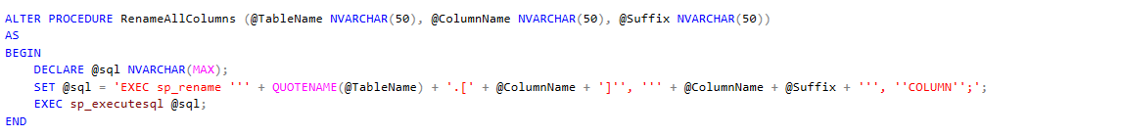

User Privileges:

I created two users for my analysis. The Public user only has access to select and view information from the table. The Intern has access to select, insert, and view stored procedures used during the analysis. The Intern was denied access to delete data from any table. In addition, there is an Admin user specified during the SQL Server application.

